Spatial and temporal visualisation techniques for crash analysis
Charlotte Plugª, Jianhong (Cecilia) Xia^{b, ,} and Craig Caulfield^{c}
ª Gaia Resources, Australia
^{b} Curtin University, Department of Spatial Sciences, Australia
^{c} Edith Cowan University, Faculty of Computing, Health and Science, Australia
Received 30 September 2010;
revised 4 April 2011;
accepted 8 May 2011.
Available online 20 June 2011.

Abstract: Understanding the underlying structure of single vehicle crashes (SVCs) is essential for improving safety on the roads. Past research has found that SVCs tend to cluster both spatially and temporally. However, limited research has been conducted to investigate the interaction between the location of SVCs and the time they occur, especially at different levels of scales or spatial extents.

This paper applied spatial, temporal and spatio-temporal techniques to investigate patterns of SVCs in Western Australia between 1999 to 2008, at different levels of scale. Spider graphs were adapted to identify temporal patterns of vehicle crashes at two different levels of scales: daily and weekly with respect to their causes. The spatial structures of vehicle crashes were analysed using Kernel Density Estimation analysis at three different scales: West Australia, Metropolitan area, and Perth Local Government Area (LGA). These are illustrated using spatial zooming theory. Comap was then used to demonstrate the spatio-temporal interaction effect on vehicle crashes. The results show significant differences in spatio-temporal patterns of SVCs for various crash causes. The techniques used here have the potential to help decision makers in developing effective road safety strategies.

Keywords: single vehicle crashes (SVCs); Geographic Information Systems (GIS); kernel density estimation; spider graph; Comap; spatio-temporal zooming theory; scale; spatial and temporal visualisation
1. Introduction

Traffic crashes have been and continue to be a major contributor of human and economic costs to society. Although authorities have implemented preventative measures and improved infrastructure, vehicle crashes remain an important issue in Western Australia (Australia Automobile Association 2008). Of particular concern are single vehicle crashes (SVCs): those that involve only one moving vehicle and include collisions, for example with pedestrians, animals, fixed objects, and non-collisions, for example roll-overs (Marchant et al. 2008). Of the 209 fatal crashes in WA in 2008, over 80 per cent were a result of a SVC (Office of Road Safety 2008). There is, therefore, an imperative need to understand the location, time and reasons for these crashes and develop strategies to prevent them.

Much research effort has been spent on investigating SVCs (Geedipally and Lord, 2010; Ivan et al., 1999; Jung et al., 2010; Mayhew et al., 2003; O'Connor and Brown, 2006; Shankar and Mannering, 1996). However, only limited research has been carried out to investigate the spatial and temporal patterns of SVCs at different scale levels (Freundschuh and Egenhofer, 1997; Li et al., 2007).

Some studies have concentrated on finding where crashes occur most frequently, such as spatial hot-spots, using spatial autocorrelation methods such as Getis-Ord Gi* (Barnao 2009; Erdogan 2009; Getis and Ord, 1992). A particular drawback of the Getis-Ord hot spot analysis is that it requires aggregation of data, instead of using individual crash locations. The analysis is based on a count or ratio of crashes in an area under study divided into smaller units known as the modifiable area unit problem. In this case, an analysis might produce different results depending on the scale and location of the aggregation units used (O'Sullivan and Unwin 2003). Kernel Density Estimation (KDE) can avoid these problems by performing analysis on a point dataset. In a vehicle crash analysis, the KDE will calculate the density of vehicle crashes around each individual vehicle crash (Anderson, 2009; Silverman, 1986). The output of a KDE analysis is a raster layer with pixels assigned values according to point intensity. It is therefore particularly useful for visualisation since areas of high crash intensity will be clearly identified (O'Sullivan and Unwin 2003).

Considerably less research has been dedicated to temporal patterns of SVCs (Li et al., 2007). In particular, methods to identify and visualise temporal hot-spots (i.e. times when crash frequency is particularly high) have not been adequately examined in previous research. These temporal studies have tended to focus on the fluctuation of the quantity and rate of crashes at different temporal scales, such as hourly, daily, monthly, and yearly (El-Sadig et al., 2002; Levine et al., 1995), and the temporal analysis results were mainly presented in table form or line graphs, which do not do justice to the value of this data. Instead, spider plots can be used to illustrate the chronological nature of the temporal data and highlight the temporal hot-spots, which assist in better understanding the change of vehicle crashes over time (Asgary et al., 2010).

Currently, three major spatial and temporal pattern analyses and visualisation techniques have been applied in vehicle crash research: map animation, isosurface method and comap (Asgary et al. 2010). Traditionally, a map animation technique was used to illustrate spatial-temporal patterns (Dorling, 1992; Moellering, 1976; Tobler, 1970). Multiple screenshots or video showing how a distribution alters over time provided a clear visual demonstration of the process. However, in order to comprehend the difference over time, this kind of illustration requires audiences to go back to previous screen-shots or to replay the video in order to re-examine a pattern. Patterns over a whole time period are not illustrated.

Isosurface methods overcome this limitation by introducing a time dimension over a 2D spatial space (Brunsdon et al., 2007; Whitaker et al., 2005). The likelihood of a crash occurring at a location (x, y) at time t can be estimated using a three-dimensional kernel density estimation algorithm and visualised in a three-dimensional space. However, this method has a considerable computation cost to generate a map.

The Comap method is useful for highlighting differences in a crash pattern using ‘small multiples’ of diagrams (Brunsdon et al., 2007). A time period, as a third dimension, is broken down into a series of time intervals and a spatial pattern can then be analysed and illustrated for each time interval. For example, Asgary et al. (2010) used the comap method to successfully illustrate how patterns in the spatial distribution of fire incidents in Toronto varied with time. The method underlined particular areas that were associated with a high fire risk at a particular time. For our study, Comap was used to show the density of crashes over time.

This paper applied these visualisation techniques to investigate spatial and temporal structures of SVCs at different scale levels. Spatial zooming theory was then applied to understand the scale issues of SVCs, and spider plots, Kernel Density Estimation and Comap were used to identify SVCs patterns in Western Australia between 1999 and 2008.

2. Methods
2.1 Study area and data collection methods

This paper is based on data obtained from Main Roads Western Australia. The Main Roads database contains information about all police-reported vehicle crashes in Western Australia. Only those crashes which occurred between 1999 and 2008 are included in the report. The study area and the distribution of all SVCs throughout the area are illustrated in Figure 1. Crashes are categorised as metropolitan or non-metropolitan based on the classification of relevant roads provided by Main Roads.

Figure 1: Distribution of all SVCs in Western Australia, 1999-2008

2.2 Spatial and temporal analysis techniques

2.2.1 Spider Plot
The time at which vehicle crashes occur is valuable for understanding the factors underlying crashes and improving infrastructure and emergency response. However, temporal hot-spots have not been adequately highlighted in previous analyses. Presenting frequency counts in table form, as in Main Roads reports (Marchant et al. 2008, Main Roads Western Australia 2009), does not fully represent the value of these data.

Instead, temporal data could be shown using line graphs or spider plots as fire incidents have been represented by Asgary et al. (2010). Of particular interest to this paper are spider graphs, also known as star charts or radar graphs. As first used by Georg von Mayr (Mayr 1877), these methods of illustration highlight the chronological nature of the data and will assist in visualising the change of vehicle crashes over time. Because a spider plot has no beginning or end due to its circular nature, it is easier to examine intervals of time that are not shown as continuous on the line graph (e.g. 6pm to 6am). Also, since the graph represents a clock, only a glance is required to comprehend the information (See Figure 3).

In this paper, the crash data across Western Australia from 1999 to 2008 have been mined to better understand the temporal nature of crashes. Three types of temporal analyses have been performed:
- Comparison of the temporal distribution of SVCs to all vehicle crashes (that is, both multi-vehicle crashes and single vehicle crashes).
- Identification of the temporal distribution of crash frequency according to the day of the week.
- Identification of the temporal distribution of crash frequency of SVCs related to different factors, such as fatigue and speeding.

2.2.2 Kernel Density Estimation

The KDE is one of the most common and well-established methods used to identify spatial patterns. It creates a field representation of SVCs: the density of SVCs for each pixel in the output raster is calculated by counting the number of crashes in a defined region, or kernel, surrounding the particular pixel. Thus, a discrete density surface is made continuous by interpolation. Darker colours highlight locations of high crash intensity. (O'Sullivan and Unwin 2003). This study applied the KDE method to estimate the intensity of SVCs (or hot-spots) at different spatial scales: WA, Metropolitan area and Perth LGA. The Spatial Analyst KDE tool in ESRI’s ArcGIS 9.3 software was used to calculate the KDE (ESRI 2010). More detailed methods can be found in (O’Sullivan & Unwin; 2003; Silverman 1986).

Although there are a wide range of KDE functions to choose from, most agree that the kernel function will not significantly impact results (Silverman 1986, Bailey and Gatrell 1995), However, the choice of bandwidth h will certainly impact density patterns. For example, if the size of the bandwidth was the same as that of the region, the density would be the same throughout the region. A very small bandwidth, however, will produce inadequate smoothing and simply highlight individual points (O'Sullivan and Unwin 2003). The effect of bandwidth choice is illustrated in Figure 2. Essentially, a larger bandwidth will consider more crash events, which will result in a smoother output raster. Often it takes trial and error to produce an appropriate KDE.

Figure 2: Effect of bandwidth choice

While it may be beneficial to examine the distribution of vehicle crashes on a large scale basis, the distribution of crashes will be primarily influenced by factors at a micro scale (Xie and Yan 2008). Therefore, the KDE was first applied to all SVCs in Western Australia simply to determine hot-spots. Two of these clusters of SVCs were then singled out and used as basis for further KDE to examine the spatial variation at a more meaningful scale.

2.2.3 Comap

Comap is an exploratory analysis technique that allows for the investigation of a pattern in multivariate data before attempting formal statistical modelling (Brunsdon 2001). The method works by sub-dividing the data according to time of occurrence. Then, different groups are analysed using certain spatial pattern identification tools such as KDE. The results are represented in a number of diagrams or maps and arranged sequentially in order to highlight changes over time. Thus, having examined the variation in the distribution of SVCs over time (i.e. temporal analysis) and across space (i.e. spatial analysis), Comap can be used to identify how the spatial distribution of crashes might vary over time. The time can be at different scale levels, i.e., hour, day and month. For the purpose of our investigation, we explored the temporal variations in the spatial distribution of crashes given different time of the day and different days of the week.

Asgary et al. (2010) outlined the steps to be taken when performing a Comap analysis. Firstly, the SVC events must be subsetted according to the hour in which they occurred (i.e., variable z). Then, a KDE can be calculated for each subset. Finally, the resulting KDE surfaces are to be arranged sequentially to illustrate how the spatial distribution of vehicle crashes changes throughout the day.

According to Asgary et al. (2010) and Corcoran et al (2007), the classification process (i.e., the classes chosen for the events) can negatively influence the Comap result. If subsets are too small, such as hourly sets for example, a pattern that should ensue may not be evident. Therefore, it is suggested that the class boundaries overlap each other and each class should have a similar number of events. Furthermore, Brunsdon (2001) requires that the mapping method for each subset must be identical so that the only difference in each of the panels is the SVC spatial distribution.

In addition, as vehicle crashes are best studied at a micro scale (Xie and Yan 2008), it would not be particularly useful to examine how the distribution of SVC changes across the whole of Western Australia temporally. Therefore, in this study, the Comap method has been applied to a number of subsets of the SVC data to analyse crashes in the Perth LGA area in details.

We improved the Comap method applied by Asgary et al. (2010) and Corcoran et al (2007) by integrating spider graphs into the Comap system. Spider graphs can illustrate continuous changes of the frequency or ratios of SVCs over a time granularity such as hours within a day. Comap can also explore spatial distribution of the SVCs at an ordered time interval, such as 3-6PM or 5-7PM, over a day. Therefore, hotspots of SVCs over space (from Comap) and time (from spider graph) can be compared. Furthermore, we conducted this comparison using spider graphs and bivariate Comap to illustrate SVC distribution by causes: pedestrian and object collision (see Figure 9). This can improve our understanding of the influence of socioeconomic and environmental factors on the SVCs from spatial and temporal views.

In summary, the advantages of Comap are as follows:
- Capable of illustrating spatial distribution changes of SVCs over time in a single visualisation;
- Capable of subsetting data into classes of interest, i.e., by time or by cause in order to investigate data in a more detailed level;
- Capable of comparing hotspots of the SVCs over space and time by integrating spider graphs into Comap, and thereby enhancing understanding of location and time dependence and location advantage (or in our case, location disadvantage).

A limitation of the Comap technique is that it overlaps class boundaries so that a similar amount of data can be located into each class (Corcoran et al, 2007). This method can be improved by introducing classification methods such as the Jenks Natural Breaks (Jenks, 1967). This helps highlight the overall variations in the temporal distribution of crashes by reducing the variance within classes and maximising the variance between classes.

2.3 Spatio- temporal zooming theory

Different levels of detailed spatial and temporal information can be represented in one map using zooming theory. A single zooming model displays a sequence of layers of gradually simplified representations from fine-grained views (articulations) to coarser-grained views (abstractions) for a given geographical map. Multiple zooming techniques can focus on information of interest with high resolution and present background information with low resolution in one map (Frigioni and Tarantino, 2003; Hornsby and Egenhofer, 2002). This paper applied single zooming theory to the data to illustrate spatial patterns of SVCs at three scales: Western Australia as a whole, the Perth metropolitan area, and the Perth Local Government Area (LGA) (See Figure 6).

3. Results
3.1 Temporal analysis

Temporal analyses were performed using spider plots. After examining the overall temporal distribution of all vehicle crashes (AVCs), the dataset was subsetted and spider plots were generated for SVCs. This provided a better understanding of the variation that exists between SVCs and AVCs. Then, attention was given to the factors related to SVCs and temporal distribution over the days of the week.

3.1.1 Overall Temporal Distribution

Figure 3 illustrates how the number of AVCs across Western Australia from 1999 to 2008 varied throughout the day compared to the SVCs in both metropolitan and non-metropolitan areas. It is evident that the temporal distributions for AVCs and SVCs are different. While AVC frequency peaks between 8-9AM and 3-6PM (during peak hour traffic), the crashes involving single vehicles are more evenly distributed throughout the day with the highest frequency between 3PM and midnight and a slight peak between 10PM and midnight. Most SVCs occur during the night when traffic volume is low and drivers are less likely to hit another car (Ivan et al., 1999). Whether light conditions or darkness significantly contributes to SVCs is still inconclusive (Ivan et al., 2000; Savolainen and Mannering, 2007). But Bernat et al (2004) demonstrated that alcohol might be one of the major factors causing late-night SVCs.

By classifying vehicle crashes as either metropolitan or non-metropolitan, it is evident, firstly, that a very large proportion of SVCs occur in non-metropolitan areas (unlike AVCs). SVCs in non-metropolitan areas tend to occur most frequently during the afternoon and night with the highest frequency between 3-7PM at which time many people are commuting home after a day at work. SVCs in metropolitan areas are most frequent later in the night, from 8-11PM when people are travelling home after social activities such as dining in restaurants.

Figure 3: Temporal distribution of all (AVCs) compared to SVCs

3.1.2 Type of SVCs by factors

Attention is now given to a number of factors that have been found to be related to vehicle crashes. The temporal distributions of speed, inattention, and fatigue-related crashes are illustrated in Figure 4. This analysis was based on police-reported information, which may lack accuracy because of insufficient reliability and some degree of uncertainty of the data (Amoros et al., 2007)

Figure 4: SVCs temporal distribution by related factors

Although the distribution of inattention-related crashes is fairly similar to the overall SVC temporal distribution, the distributions of speed- and fatigue-related crashes are markedly different. However, some variation does exist: inattention-related crashes are more frequent from 6PM to midnight.

Speeding in this study refers to driver exceeding the authorised speed limit. For both metropolitan and non-metropolitan crashes, those for which speeding was a factor are obviously most frequent during the night (from 7PM – 2AM) with a peak around midnight. It could be said that either drivers are more likely to speed at night or that speeding is more likely to result in a SVCs during the night (perhaps because of other factors such as alcohol, inattention, and roads with poor lighting). According to Chen et al. (2009), a higher proportion of SVCs in non-metropolitan areas could be associated with speeding than in metropolitan areas.

Fatigue-related crashes are most common in non-metropolitan areas, particularly between 1-2AM and 2-4PM, while metropolitan fatigue crashes are also frequent in the early hours of the morning. Overall there are proportionally many SVCs between 2-6AM in metropolitan areas, but there are proportionally fewer fatigue-related crashes during the day, especially in the afternoon.

3.1.3 The Days of the Week

The temporal distribution of crash frequency can also be analysed by comparing variation according to the days of the week, as shown in Figure 5.

Figure 5: SVC temporal distribution over the days of the week

Firstly, it is clear that the SVC distribution over the time of the day exhibits a different pattern on weekdays and weekends. During the week, crashes appear to be more frequent in the afternoon and night (3PM – midnight), while many weekend crashes occur late at night and early in the morning (10PM – 2AM). There is little temporal variation from Monday through to Thursday, although SVC frequency increases towards the end of the week. SVCs are particularly common on Friday nights, with the frequency increasing from 5PM until a peak is reached at midnight. Interestingly, many crashes on Saturday occur between 11PM and 1AM and many crashes on Sunday night occur an hour later, between midnight and 3AM, which might be explained by the findings of alcohol related night-time SVCs conducted by Bernat et al. (2004).

3.2 Spatial analysis

Figure 6 displays a KDE performed at different spatial scales for SVCs. It is evident that different levels of information are exhibited at different scales. As shown, KDE was first calculated for all SVCs in Western Australia. This was followed by a KDE for only metropolitan SVCs. Finally, crashes in the Perth Local Government Area were considered. Because Western Australia is such a large region with widespread variation of SVC frequency, this multiple scale approach is particularly suitable. Performing KDE on the whole of Western Australia is useful for identifying primary hotspots: regions where crashes are most frequent. The results show that crashes are particularly clustered around the Perth metropolitan region as would be expected. A KDE of crashes in just this region was conducted. Figure 8 reveals that SVCs are clustered throughout the Metropolitan area, but more so in the centre of the region. Therefore, a KDE was also performed on those crashes within the Perth Local Government Area. This small scale map illustrates the clustering that occurs at particular intersections (See Figure 6).

Figure 6: Spatial pattern of SVCs at different scale levels

3.3 Spatio- temporal analysis

It is evident from the previous section that the distribution of SVCs varies considerably over Western Australia. Clustering occurs at major centres and along main routes throughout the state. Also, SVC distribution fluctuates over the time of the day and the days of the week. By combining the variation in temporal and spatial distribution, the Comap method was used to examine whether the spatial distribution is subject to temporal fluctuation.

It is expected that changes in the spatial distribution throughout the day or week will vary for different places. Figure 7 illustrates how the spatial distribution of SVCs in Perth varies according to the days of the week. It is evident that crashes tend to be clustered in the northern parts of the suburb on weekends, while there are comparatively few crashes there on working days. This area is vibrant with cafés, restaurants, bars, shops, nightlife, and cultural events and frequented for shopping, eating and socialising. On the other hand, on weekdays crashes frequently occur in the Central Business District (CBD), particularly around the St Georges Tce, Barrack St, William St and Wellington St block.

Figure 7: Comap for SVCs in Perth (by the days of the week)

The spatial variation of SVCs in Perth due to the time of the day is illustrated in the comap analysis in Figure 8. As shown by the spider graph, crashes occur most frequently between 8-9AM, 12-1PM, 3-6PM, and late at night when city workers commute and break for lunch. Crashes tend to happen in the northern part of the suburb and on the Graham Farmer Freeway during very late hours and early in the morning, which are the transition areas between Perth city and the other suburbs. Although there are relatively few crashes between 4-7AM, quite a number occur on Stirling Street and a transition in spatial distribution towards the south of the suburb is evident. As the day progresses, SVCs become increasingly clustered in the CBD (the southern areas of the suburb). Clustering is especially evident here from 3-6PM. Later in the evening clustering tends to occur at the beginning of the Kwinana Freeway. Crashes at the causeway (east of the suburb) occur throughout the day.

Figure 8 Comap for SVCs in Perth (by the hours of the day)

Figures 8 shows univariate comaps, or comaps demonstrating how distribution changes for a single variable such as one type of SVCs across space and over time. A bivariate comap allows the spatio-temporal distribution of two variables to be compared. This will help in understanding if the types of SVCs or the factors related to SVCs have unique distributions.

The spatio-temporal variation between hitting-pedestrians and hitting-objects SVCs are evidently different (See Figure 9). The spider graphs demonstrate that while object crashes generally occurred during the night from 10PM-4AM, pedestrian crashes were most common around 8-9AM, 12PM, and 3-6PM because of the high volume of the pedestrians on the street. A bivariate comap for pedestrian- and object-collisions SVCs is given in Figure 9. The pedestrian crashes at night are evidently clustered in the northern part of the suburb (the Northbridge entertainment district). During the day pedestrian crashes are more common in the city centre (St George’s Terrace, Barrack Street, William Street and Wellington Street) and some clustering occurs in the area to the west (Subiaco). Object crashes do not exhibit the same degree of clustering as pedestrian crashes. However, they do appear to be most common on the freeways and causeway. In the afternoon and evening many occur on Barrack Street, while late at night they tend to be located on Wellington Street between where it intersects with Barrack and William Street.

Figure 9: Comap for comparison of SCV pedestrian and object collisions in Perth (by the hours of the day)

4. Implication

Identification of spatial and temporal distribution patterns of vehicle crashes and their associated risk factors can provide some guidance to intervention planners where and when they should implement intervention action plans. For example, for both metropolitan and non-metropolitan crashes, vehicle crashes in relation to speeding were most frequent during the night (from 7PM – 2AM) with a peak around midnight. Therefore, during this time period, especially around peak time of vehicle crashes, we recommend more strict enforcement of speed limits on certain streets where SVC hot spots occurred. In fact, Main Roads, an organisation responsible for highways and main roads management in Western Australia, is planning to decrease speed limit from 50KM/h to 40KM/h on some streets in Perth CBD area by mid-year, 2011 (The Weekend West, 2011).

Some interesting temporal and spatial patterns were indentified in this study. For example, the number of vehicle crashes increases from Monday to Friday, peaks on Saturday, and then starts to decrease from Sunday. Fatigue-related crashes are most common in non-metropolitan areas, particularly between 1-2AM and 2-4PM. Metropolitan fatigue crashes are also frequent in the early hours of the morning, while object crashes appear to be more common on the freeways and causeway. During the day, pedestrian crashes are more common in the city centre due to high volume of pedestrians, and around school zones between 3:00-5:00PM. This spatial and temporal crash information would be helpful for possible interventions such as improved signage, drink driving control, improvements for school zones, pedestrians and cyclists, and improved infrastructure in highways.

5. Conclusions

The primary goal of this paper was to explore different spatial and temporal visualisation technologies to reveal patterns and significant factors of vehicle crashes.

Pattern and process: Spatial and temporal visualisation techniques applied in this paper reveal not only vehicle crash patterns at a certain area and time period but also demonstrate the process underlying these crash patterns. For example, spatial and temporal hotspots illustrated by KDE and spider graph methods and Comap can show the changes of patterns during a certain time period. By intersecting these patterns and known risk factors such as speed and fatigue, some significant factors can be identified to understand reasons behind certain patterns.

A systematic method: Scale plays a vital role in influencing people’s perception of space and time (Freundschuh and Egenhofer, 1997). People tend to abstract spatial and temporal information from their environment at different scales and conduct mental shifts among these different scales (Hornsby, 2001). Effective visualisation and analysis depend critically on choosing an appropriate scale in order to derive a meaningful outline of the data (Shchaffer et al., 1996). This paper provided a systematic approach to investigate the spatial and temporal patterns and processes at different levels of scales. This approach will be very useful in guiding GIS analysts in choosing the best level of detail for their analysis.

Limitation: A notable limitation of the current study is that the results achieved could be relative to the classifications inherent in the Comap method: time point data has been grouped into time intervals and the intervals chosen will affect the KDE result. However, care has been taken to select a classification scheme that best highlights the overall temporal distribution by using the natural breaks that occur within the distribution. As evident by comparing the spider graphs alongside the comap results, the temporal distribution varies for the different data subsets analysed in the comaps. Despite this, the same class boundaries were applied to all Comap analyses in order to make the comparison fair.

In summary, systematic spatial and temporal crash visualisation methods can provide useful information for further research and intervention policies that can make shared public roads much safer for all users.

Acknowledgements

We wish to acknowledge the assistance of Main Roads WA in providing access to the WA road crash data files needed for this study. Thanks are extended to Daniel Grillo for editing the paper.

References

Amoros, E. M., Martin, J.-L. M., Chiron, M. M. & Laumon, B. (2007) Road crash casualties: characteristics of police injury severity misclassification,, Journal of Trauma-Injury Infection & Critical Car, 62(2), 482-490.
Anderson, T. K. (2009) Kernel density estimation and K-means clustering to profile road accident hotspots, Accident Analysis & Prevention, 41(3), 359-364.
Asgary, A., Ghaffari, A. & Levy, J. (2010) Spatial and temporal analyses of structural fire incidents and their causes: A case of Toronto, Canada, Fire Safety Journal, 45(1), 44 - 57.
Australia Automobile Association. Issues for Motorists: Road Safety. 2008. http://www.aaa.asn.au/issues/road_safety.htm (accessed April 14, 2010).
Barnao, V. Analysis of single vehicle crashes using geospatial techniques, 1999-2008. Undergraduate Project, Curtin University of Technology, 2009.
Bailey, T.C. & Gatrell, A.C. 1995. Interactive spatial data analysis. Longman, Essex, UK.
Bernat, D. H., Dunsmuir, W. T. M. & Wagenaar, A. C. (2004) Effects of lowering the legal BAC to 0.08 on single-vehicle-nighttime fatal traffic crashes in 19 jurisdictions, Accident Analysis & Prevention, 36(6), 1089-1097.
Brunsdon, C., Corcoran, J. & Higgs, G. (2007) Visualising space and time in crime patterns: A comparison of methods, Computers, Environment and Urban Systems, 31(1), 52-75.
Chen, H. Y., Ivers, R. Q., Martiniuk, A. L. C., Boufous, S., Senserrick, T., Woodward, M., Stevenson, M., Williamson, A. & Norton, R. (2009) Risk and type of crash among young drivers by rurality of residence: Findings from the DRIVE Study, Accident Analysis & Prevention, 41(4), 676-682.
Corcoran, J., Higgs, G., Brunsdon, C., & Ware, A. (2007). The Use of Comaps to Explore the Spatial and Temporal Dynamics of Fire Incidents: A Case Study in South Wales, United Kingdom. The Professional Geographer, 59(4), 521-536.
Dorling, D. (1992) Stretching Space and Splicing Time: From Cartographic Animation to Interactive Visualization, Cartography and Geographic Information Science, 19215-227.
El-Sadig, M., Nelson Norman, J., Lloyd, O. L., Romilly, P. & Bener, A. (2002) Road traffic accidents in the United Arab Emirates: trends of morbidity and mortality during 1977-1998, Accident Analysis & Prevention, 34(4), 465-476.
Erdogan, S. “Explorative spatial analysis of traffic accident statistics and road mortality.” Journal of Safety Research 40, no. 1 (2009): 341-351.
ESRI (2010) ArcGIS 9.3. New York, ESRI.
Freundschuh, S. & Egenhofer, M. (1997) Human Conceptions of Spaces: Implications for Geographic Information Systems, Transactions in GIS, 2(4), 361-375.
Frigioni, D. & Tarantino, L. (2003) Multiple zooming in geographic maps, Data & Knowledge Engineering, 47(2), 207-236.
Getis A and Ord JK, (1992),The Analysis of Spatial Association by Use of Distance Statistics. Geographical Analysis, 24, 189-206.
Geedipally, S. R. & Lord, D. (2010) Investigating the effect of modeling single-vehicle and multi-vehicle crashes separately on confidence intervals of Poisson-gamma models, Accident Analysis & Prevention, 42(4), 1273-1282.
Hornsby, K. (2001) Temporal zooming, Transactions in GIS, 5(3), 255-272.
Hornsby, K. & Egenhofer, M. (2002) Modelling Moving Objects over Multiple Granularities, Annals of Mathematics and Artificial Intelligence, 36, 177-194.
Ivan, J. N., Pasupathy, R. K. & Ossenbruggen, P. J. (1999) Differences in causality factors for single and multi-vehicle crashes on two-lane roads, Accident Analysis & Prevention, 31(6), 695-704.
Ivan, J. N., Wang, C. & Bernardo, N. R. (2000) Explaining two-lane highway crash rates using land use and hourly exposure, Accident Analysis & Prevention, 32(6), 787-795.
Jung, S., Qin, X. & Noyce, D. A. (2010) Rainfall effect on single-vehicle crash severities using polychotomous response models, Accident Analysis & Prevention, 42(1), 213-224.
Jenks, George F. (1967) The Data Model Concept in Statistical Mapping, International Yearbook of Cartography, 7, 186-190.
Levine, N., Kim, K. E. & Nitz, L. H. (1995) Spatial analysis of Honolulu motor vehicle crashes: I. Spatial patterns, Accident Analysis & Prevention, 27(5), 663-674.
Li, L., Zhu, L. & Sui, D. Z. (2007) A GIS-based Bayesian approach for analyzing spatial-temporal patterns of intra-city motor vehicle crashes, Journal of Transport Geography, 15(4), 274-285.
Main Roads Western Australia. Annual Report 2009, Main Roads Western Australia, 2009.
Marchant, R.J., D.L. Hill, R.A. Caccianiga, P.D. Gant. Reported Road Crashes in Western Australia 2006, Office of Road Safety: Annual Crash Statistics. September 2008. http://www.ors.wa.gov.au/ResearchFactsStats/Pages/AnnualCrashStats.aspx (accessed April 14, 2010).
Mayhew, D. R., Ferguson, S. A., Desmond, K. J. & Simpson, H. M. (2003) Trends in fatal crashes involving female drivers, 1975-1998, Accident Analysis & Prevention, 35(3), 407-415.
Mayr, G. (1877). Die Gesetzmäßigkeit im Gesellschaftsleben. Oldenbourg. p.78.
Moellering, H. (1976) The potential uses of a computer animated film in the analysis of geographical patterns of traffic crashes, Accident Analysis & Prevention, 8(4), 215-227
O'connor, P. J. & Brown, D. (2006) Relative risk of spinal cord injury in road crashes involving seriously injured occupants of light passenger vehicles, Accident Analysis & Prevention, 38(6), 1081-1086.
Office of Road Safety. 2008 Preliminary Western Australian Road Crash Fatalities, Office of Road Safety: Annual Crash Statistics. 2008. http://www.ors.wa.gov.au/ResearchFactsStats/Pages/AnnualCrashStats.aspx (accessed April 14, 2010).
O'Sullivan, D.& Unwin D.J.. Geographic Information Analysis. Hoboken: John Wiley & Sons, Inc., 2003.
Savolainen, P. & Mannering, F. (2007) Probabilistic models of motorcyclists' injury severities in single- and multi-vehicle crashes, Accident Analysis & Prevention, 39(5), 955-963.
Shankar, V. & Mannering, F. (1996) An exploratory multinomial logit analysis of single-vehicle motorcycle accident severity, Journal of Safety Research, 27(3), 183-194.
Shchaffer, D., Zuo, Z., Greenberg, S., Bartram, L., Dill, J., Dubs, S. & Roseman, M. (1996) Navigating Hierarchically Clustered Networks through Fisheye and Full-Zoom Methods, ACM Transactions on Computer-Human Interaction, 3(2), 162-188.
Silverman, B. W. (1986) Probability density estimation for statistics and data analysis. Chapman and Hall, New York.
The Weekend West (2010) Perth City plans cut in CBD speed, The Weekend West, March 5-6, 2011.
Tobler, W. R. (1970) A Computer Movie Simulating Urban Growth in the Detroit Region, Economic Geography, 46, 234-240.
Whitaker, R. T., Charles, D. H. & Chris, R. J. (2005) Isosurfaces and Level-Sets, Visualization Handbook, 97-123, Burlington: Butterworth-Heinemann.
Xie, Z. & Yan, J. (2008) Z. Kernel density estimation of traffic accidents in a network space, Computers, Environment and Urban Systems, 32(5), 396–406.

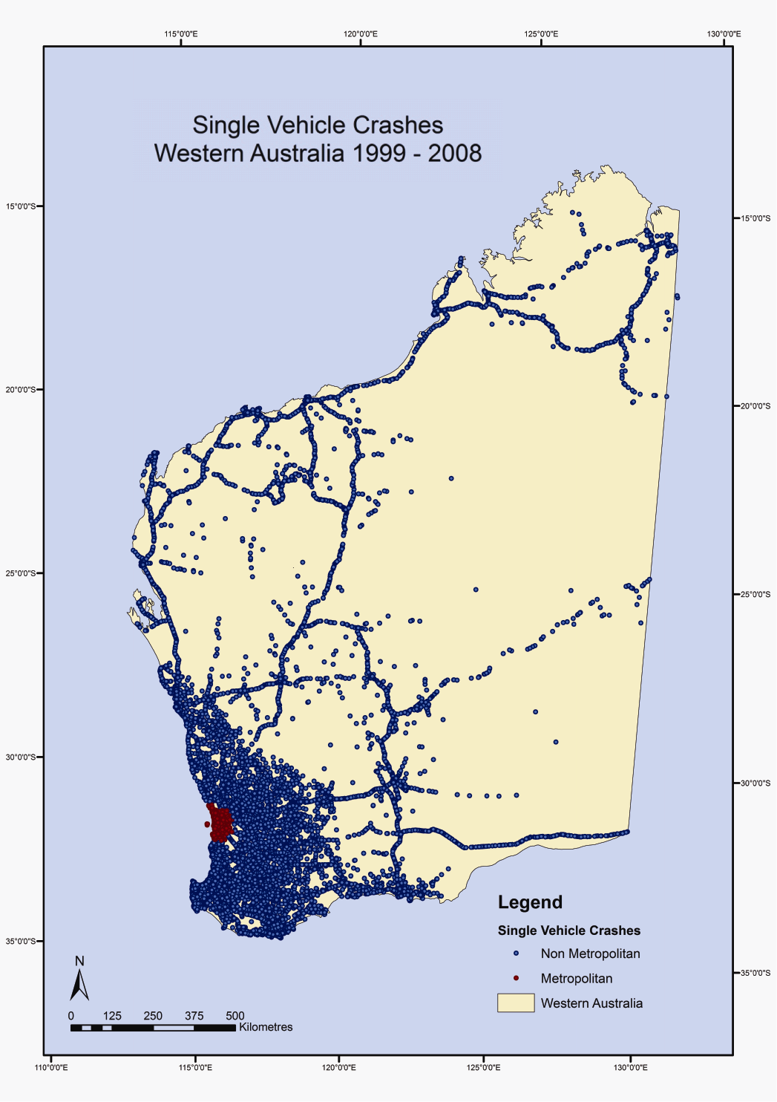
Figure 1: Distribution of all SVCs in Western Australia, 1999-2008

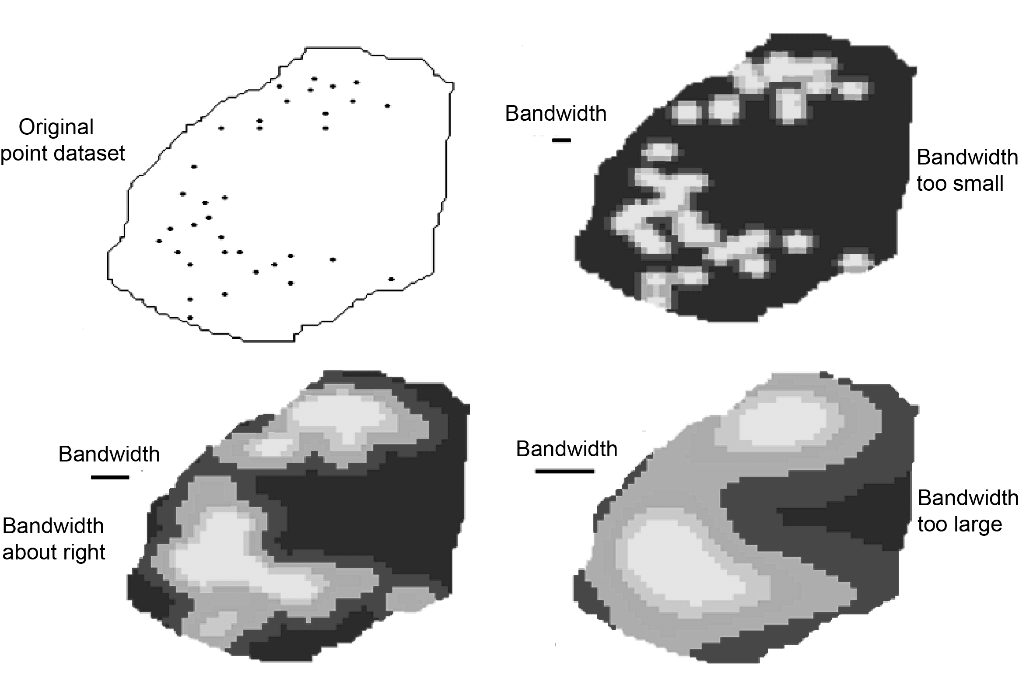
Figure 2: Effect of bandwidth choice

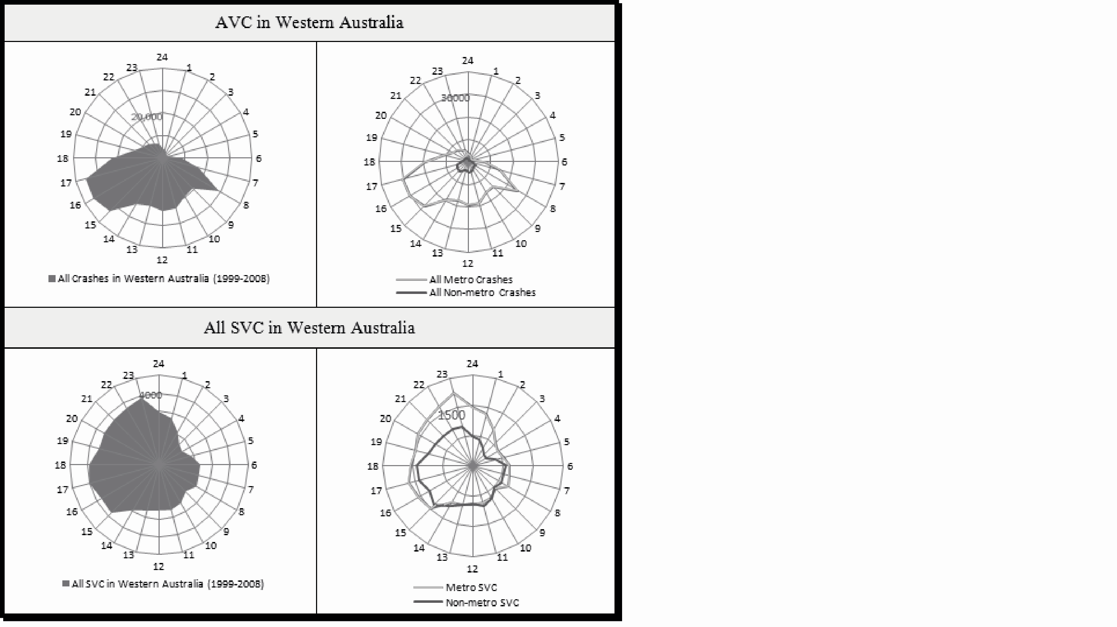
Figure 3: Temporal distribution of all AVCs compared to SVCs

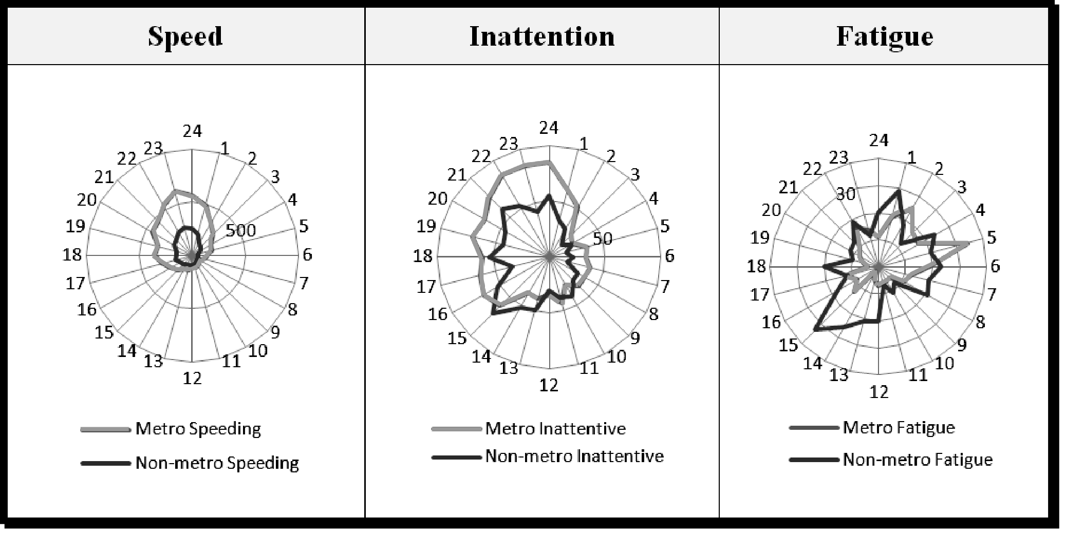
Figure 4: SVC temporal distribution by related factors
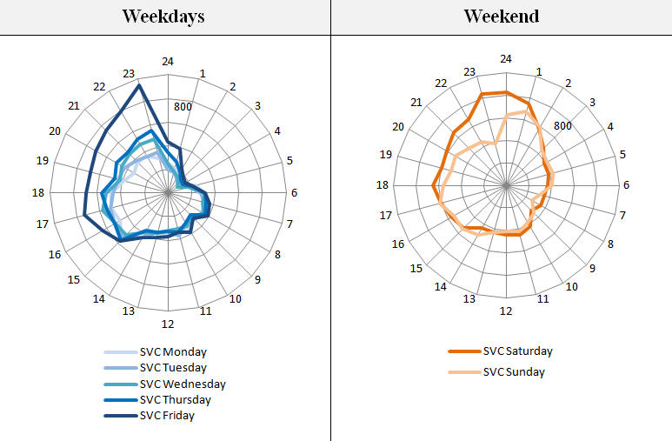
Figure 5: SVC temporal distribution over the days of the week

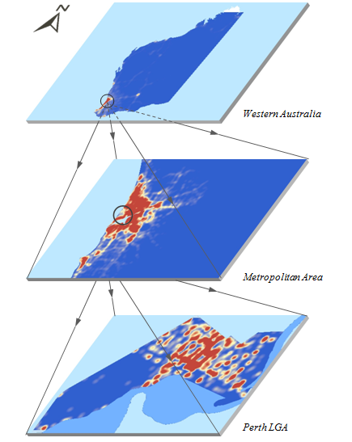
Figure 6: Spatial pattern of SVCs at different scale levels

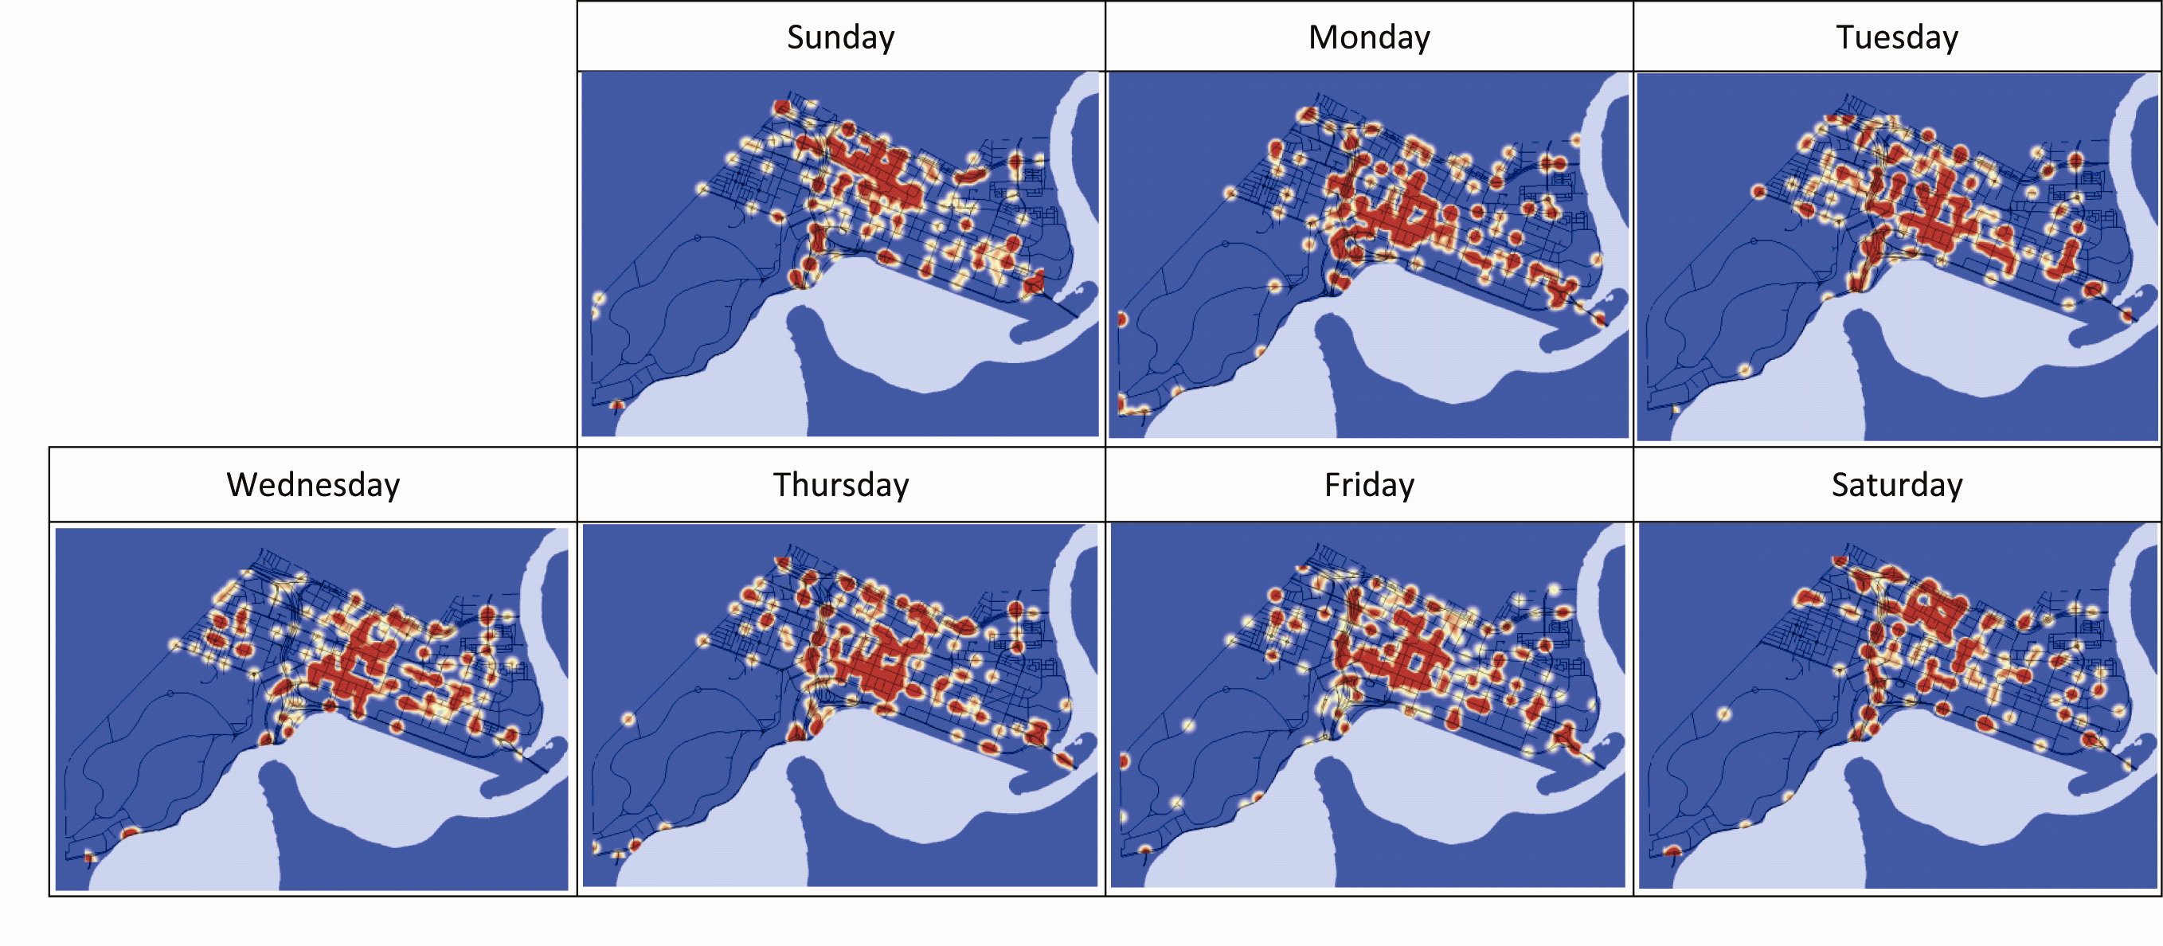
Figure 7 Comap for SVCs in Perth (by the days of the week)

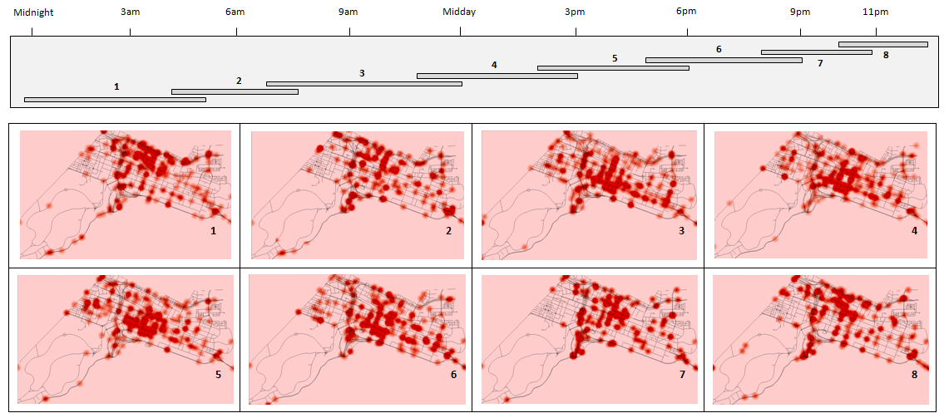
Figure 8 Comap for SVCs in Perth (by the hours of the day)

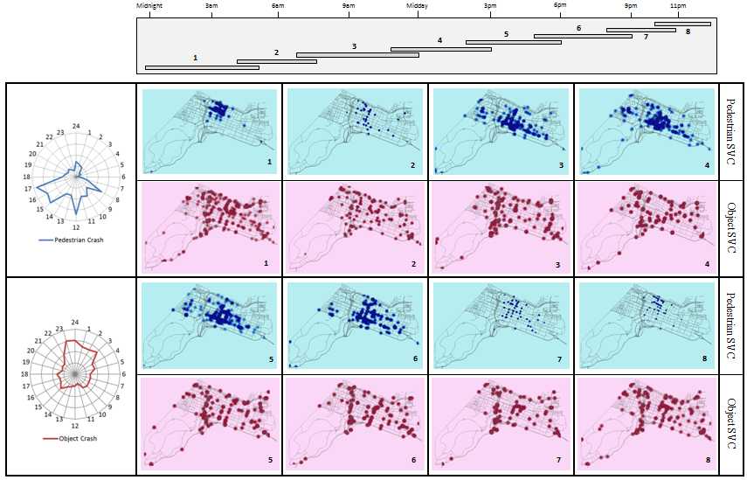
Figure 9: Comap for comparison of SCV pedestrian and object collisions in Perth (by the hours of the day)

